Unix Commands 2

Mkdir -

Mkdir -p ‘file1/file2/file3’ -



mkdir file1 file2 file3-



rmdir filename-

cp -b filename filename -

cal-

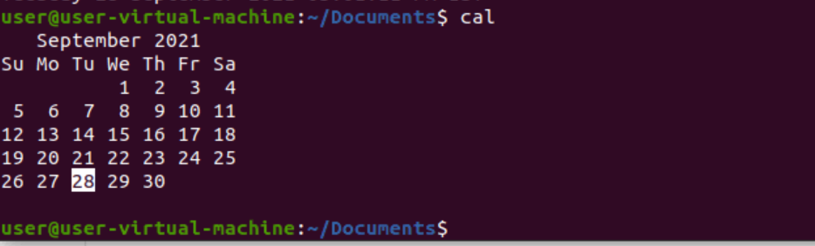

cp filen file -



cp \* .txt ‘path’ -

mkdir folder{ 1..10}-

cp filename filename -

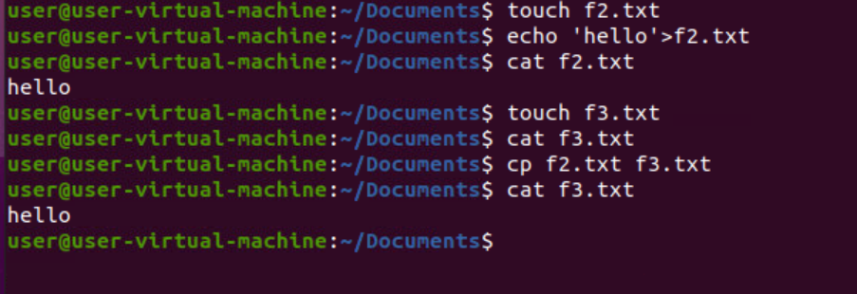

cp -i filename filename

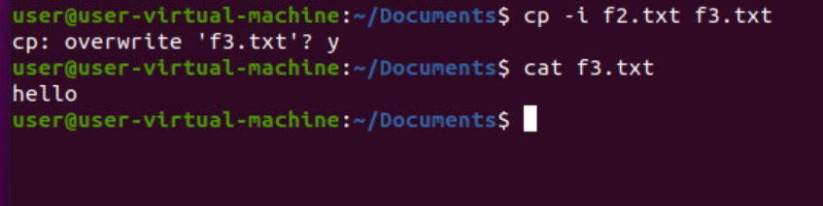

date -



mv filename location/ -



mv filename location/ -



rm rf filename -

sort -k1 filename



sort -nk1 filename

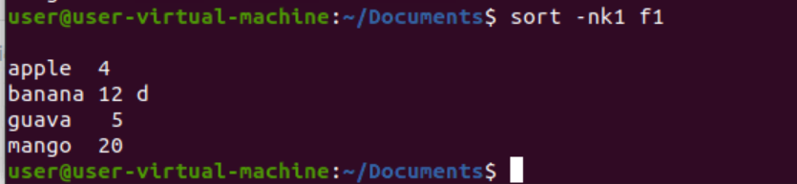

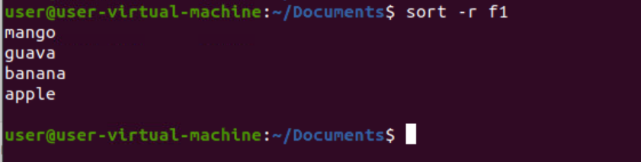Sort -r filename

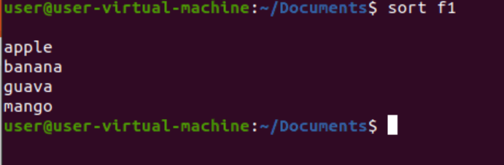sort filename

sort filename filename

touch -c filename

touch